1. Name the departments having highest number of faculties and display

the names of faculties

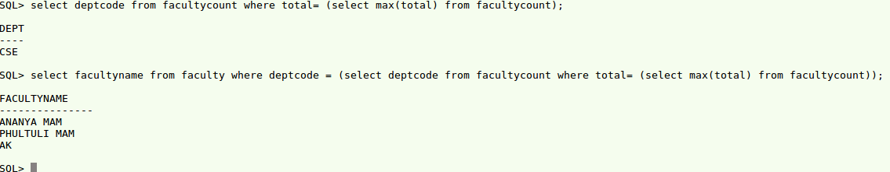

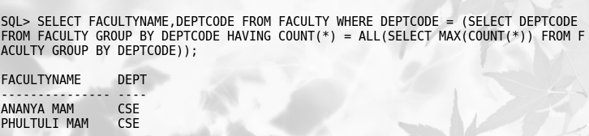

b. Create a view on the STUDENT table named V_STD selecting all the

columns. Run the following queries on the view.

i. Display all data from the view.

ii. Insert a new row into the view with the following data –

iii. Display data from student table to verify that the row has been

inserted into the Table.

iv. Update the address of Bishakh to “SectorV” & verify the change in

the table.



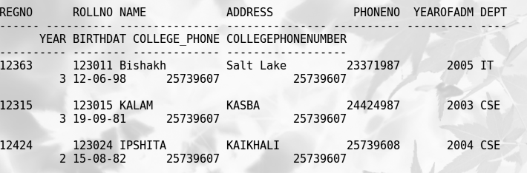

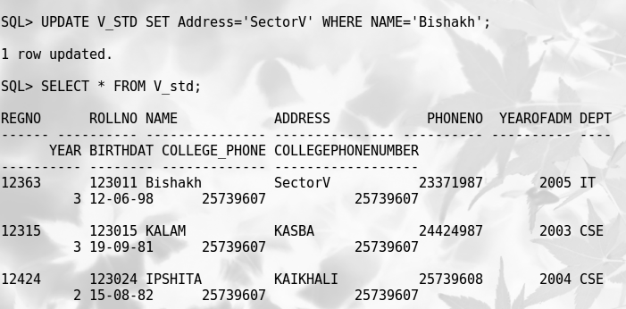

c. Create a view on student table snamed V_STD_2 selecting the

columns – RegNo, Name, Year, Deptcode.

Display data from the view.

Try to insert data into table through view.

Update the Deptcode of ‘Kamal’ to ‘IT’ through view.

Delete records of students of 4 th year through view

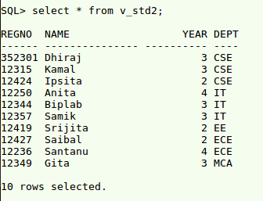

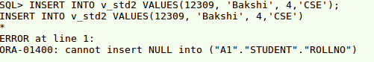





d. Create a view named V_FACULTY consisting of columns

FacultyName, DeptCode from FACULTY table and HOD from

Department table.

i. Display data from V_FACULTY

ii. Try to insert a new row into this view V_FACULTY.

iii. Try to update the DeptCode of a CSE faculty to IT.

CREATE VIEW V_FACULTY AS  
SELECT S. FACULTYNAME, S.DEPTCODE, F.HOD  
FROM FACULTY S, DEPARTMENT F  
WHERE S.DEPTCODE = F.DEPTCODE;

